Tabel Paket Produk

|  |  |  |  |
| --- | --- | --- | --- |
| PRODUK | | | |
| OPERATOR | Biaya Asesmen | Biaya Sertifikasi | Biaya Re-Sertifikasi |
| JUNIOR OFFICE OPERATOR | RP 600.000 | RP 350.000 | RP 650.000 |
| HELP DESK | RP 900.000 | RP 350.000 | RP 800.000 |
| SENIOR OFFICE OPERATOR | RP 900.000 | RP 350.000 | RP 800.000 |
| PROGRAMMING | Biaya Asesmen | Biaya Sertifikasi | Biaya Re-Sertifikasi |
| JUNIOR PROGRAMMER | RP 600.000 | RP 350.000 | RP 650.000 |
| PROGRAMMER | RP 1.000.000 | RP 350.000 | RP 950.000 |
| ANALIST PROGRAMMER | RP 3.000.000 | RP 350.000 | RP 1.850.000 |
| JUNIOR WEB PROGRAMMER | RP 600.000 | RP 350.000 | RP 650.000 |
| WEB DESIGNER | RP 1.000.000 | RP 350.000 | RP 950.000 |
| JUNIOR MULTIMEDIA PROGRAMMER | RP 600.000 | RP 350.000 | RP 650.000 |
| MULTIMEDIA PROGRAMMER | RP 1.000.000 | RP 350.000 | RP 950.000 |
| MOBILE PROGRAMMER | RP 1.500.000 | RP 100.000 | RP 1.000.000 |
| TECHNICAL | Biaya Asesmen | Biaya Sertifikasi | Biaya Re-Sertifikasi |
| JUNIOR TECHNICAL SUPPORT | RP 600.000 | RP 350.000 | RP 650.000 |
| TECHNICAL SUPPORT | RP 2.000.000 | RP 350.000 | RP 1.350.000 |
| NETWORK | Biaya Asesmen | Biaya Sertifikasi | Biaya Re-Sertifikasi |
| JUNIOR NETWORK ADMINISTRATOR | RP 600.000 | RP 350.000 | RP 650.000 |
| NETWORK ADMINISTRATOR | RP 1.000.000 | RP 350.000 | RP 950.000 |
| NETWORK ENGINEER | RP 2.000.000 | RP 350.000 | RP 1.350.000 |
| ADMINISTRATOR | Biaya Asesmen | Biaya Sertifikasi | Biaya Re-Sertifikasi |
| JUNIOR SISTEM ADMINISTRATOR | RP 600.000 | RP 350.000 | RP 550.000 |
| SISTEM ADMINISTRATOR | RP 1.000.000 | RP 350.000 | RP 950.000 |
| SISTEM ENGINEER | RP 2.000.000 | RP 350.000 | RP 950.000 |
| MULTIMEDIA | Biaya Asesmen | Biaya Sertifikasi | Biaya Re-Sertifikasi |
| JUNIOR DIGITAL ARTIST | RP 600.000 | RP 350.000 | RP 650.000 |
| DIGITAL ARTIST | RP 1.000.000 | RP 350.000 | RP 950.000 |

Form Pendaftaran

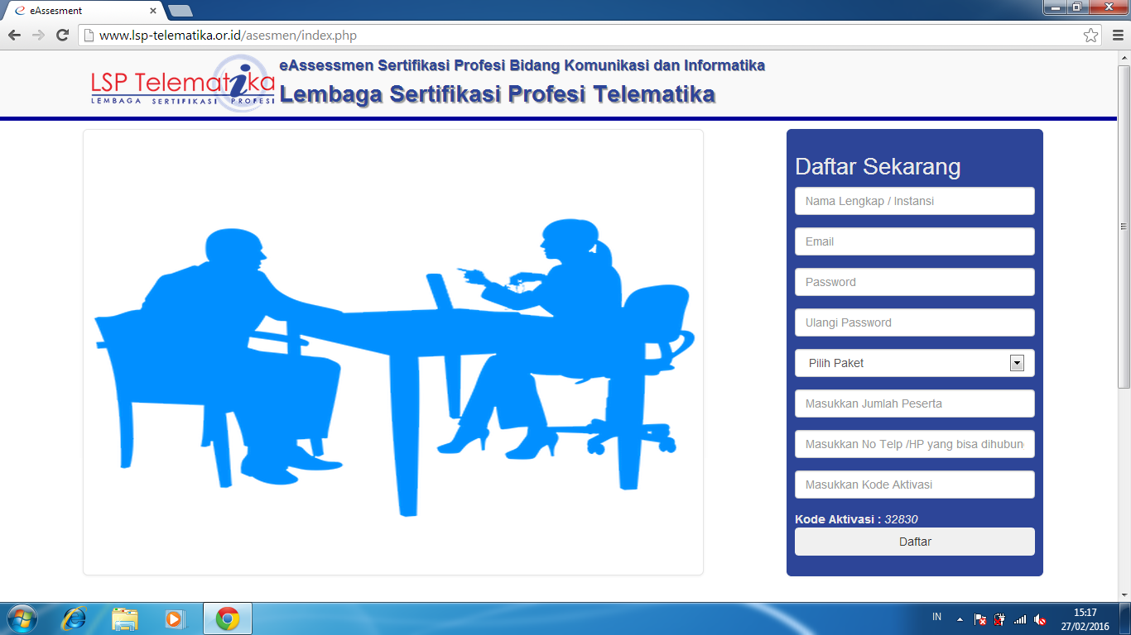

Contoh Pengisisan Form Pendaftaran

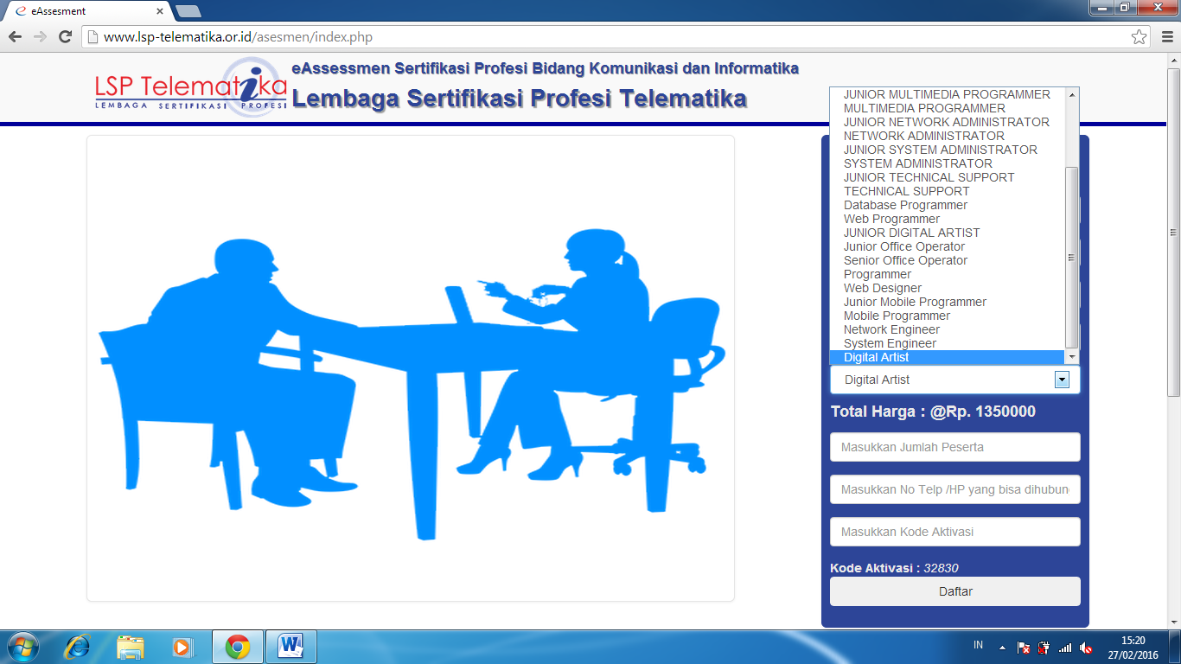

Catatan total harga : jumlah antara biaya asesmen + biaya sertifikasi